A Review of Machine Learning Based Library Management Systems
Ansari Rayyan Khalil Ahmed, Ansari Fauzan Farooque, Chorghey Musaddique Mohib Ahmed, Shaikh Hamza Aslam
Department of Computer Science,
M. H. Saboo Siddik College of Engineering, Mumbai, Maharashtra, India

Abstract
The rapid growth of digital education and online information services has placed significant pressure on academic libraries to modernize their management systems. Conventional library management approaches, which largely depend on static databases and rule-based operations, struggle to handle large collections, evolving user preferences, and the growing demand for personalized services. As a result, machine learning (ML) has emerged as a promising solution for introducing intelligence and adaptability into library systems.
This review paper presents a detailed analysis of ten recent research studies published between 2024 and 2025 that focus on the use of machine learning and artificial intelligence in library management systems. Each paper is examined based on its objectives, applied methodologies, machine learning techniques, strengths, and limitations. Through comparative analysis, this study identifies several unresolved challenges, including limited real-world deployment, strong dependency on historical datasets, absence of unified intelligent architectures, and weak integration between ML models and core library databases. The paper concludes by highlighting future research directions aimed at developing scalable, secure, and hybrid intelligent library management systems suitable for modern academic environments.

Keywords
Library Management System, Machine Learning, Artificial Intelligence, Intelligent Libraries, Recommendation Systems, Predictive Analytics

I. Introduction
Libraries have always played a central role in supporting education, research, and knowledge sharing. However, with the rapid expansion of academic resources and increasing numbers of users, managing library operations efficiently has become increasingly complex. Traditional library management systems primarily rely on predefined rules and static database operations, which limits their ability to respond dynamically to changing user behavior and usage patterns.
In recent years, machine learning has gained attention as a powerful tool for enhancing automation and intelligence in library systems. By analyzing historical borrowing records, search activity, and user interaction data, ML models are capable of identifying hidden trends and providing meaningful insights. Applications such as personalized book recommendations, demand forecasting, intelligent search mechanisms, and automated decision support have shown significant potential in improving both user experience and administrative efficiency.
Despite the growing interest in ML-based library systems, existing research efforts remain scattered. Many studies focus on specific features such as recommendation engines or prediction models, without addressing the overall system architecture. This lack of integration makes it difficult to adopt such solutions in real-world library environments. The objective of this review is to systematically examine recent research in this domain, highlight key trends, and identify gaps that must be addressed to enable practical and scalable intelligent library systems.

II. Problem Statement
Although machine learning techniques have demonstrated clear benefits in enhancing library management systems, current research lacks a standardized and unified approach. Most proposed solutions are limited to experimental prototypes, rely on small or institution-specific datasets, or operate as independent modules disconnected from core library workflows. These limitations restrict scalability, interoperability, and long-term adoption. Therefore, there is a need for a comprehensive review that evaluates recent ML-based approaches and identifies research gaps that hinder real-world implementation.

III. Literature Review
Recent studies indicate a growing shift from traditional rule-based library management systems toward intelligent, machine learning–driven solutions. Machine learning techniques are increasingly used to improve personalization, demand prediction, and decision support in modern libraries.
Dhara (2025) applied clustering and natural language processing techniques to analyze circulation data for predictive collection development. The study demonstrated the usefulness of data-driven acquisition planning but relied heavily on historical data and lacked real-time validation.
Barman (2025) and Henez (2024) provided conceptual reviews on the role of artificial intelligence and machine learning in library automation, highlighting applications such as intelligent cataloging, metadata generation, and information retrieval. However, these studies did not include experimental implementation or performance evaluation.
Daimari et al. (2025) focused on predicting user book preferences using supervised machine learning models, including ensemble classifiers. While the results showed improved prediction accuracy, the system was evaluated on limited datasets and was not integrated into a live library environment.
Mala (2024) and Desai and Gokhale (2024) explored the use of deep learning and recommendation systems in libraries, emphasizing personalization and improved user engagement. These studies highlighted theoretical benefits but lacked real-world benchmarking.
JeyaPrakash and Moorthy (2024), Meshram (2025), and Suruchi (2025) examined the broader impact of AI and ML on library services through case studies and surveys. Their findings emphasized operational efficiency and digital transformation but provided limited technical depth.
Adisesha and Reddy (2025) proposed an ML-enhanced intelligent library management system integrating prediction and recommendation features. Although the prototype demonstrated improved performance over traditional systems, scalability and long-term deployment were not evaluated.
Overall, the reviewed literature confirms the potential of machine learning in enhancing library management systems. However, most existing solutions remain fragmented, rely on limited datasets, and lack unified architectures and large-scale real-world validation.

IV. Comparative Analysis
The reviewed literature reflects a clear evolution from basic rule-based automation toward intelligent, data-driven library management systems. Machine learning techniques such as classification, clustering, and recommendation algorithms are increasingly being used to enhance decision-making and user personalization. However, most implementations treat ML components as standalone additions rather than fully integrated parts of the library management system.
Another important observation is the heavy dependence on historical data. The accuracy and usefulness of ML models often vary across institutions due to differences in collection size, user behavior, and borrowing patterns. Additionally, evaluation methods differ significantly between studies, making direct comparison challenging. These issues highlight the need for standardized datasets, benchmarking methods, and integrated system designs.

V. Research Gaps Identified
Based on the reviewed literature, the following research gaps have been identified:
- Absence of unified architectures that seamlessly integrate machine learning with core library systems
- Limited real-world deployment and long-term performance evaluation
- Strong dependency on historical datasets, affecting generalization
- Weak coupling between ML models and transactional library databases
- Insufficient consideration of data security, privacy, and ethical concerns

VI. Proposed System Architecture and Figures
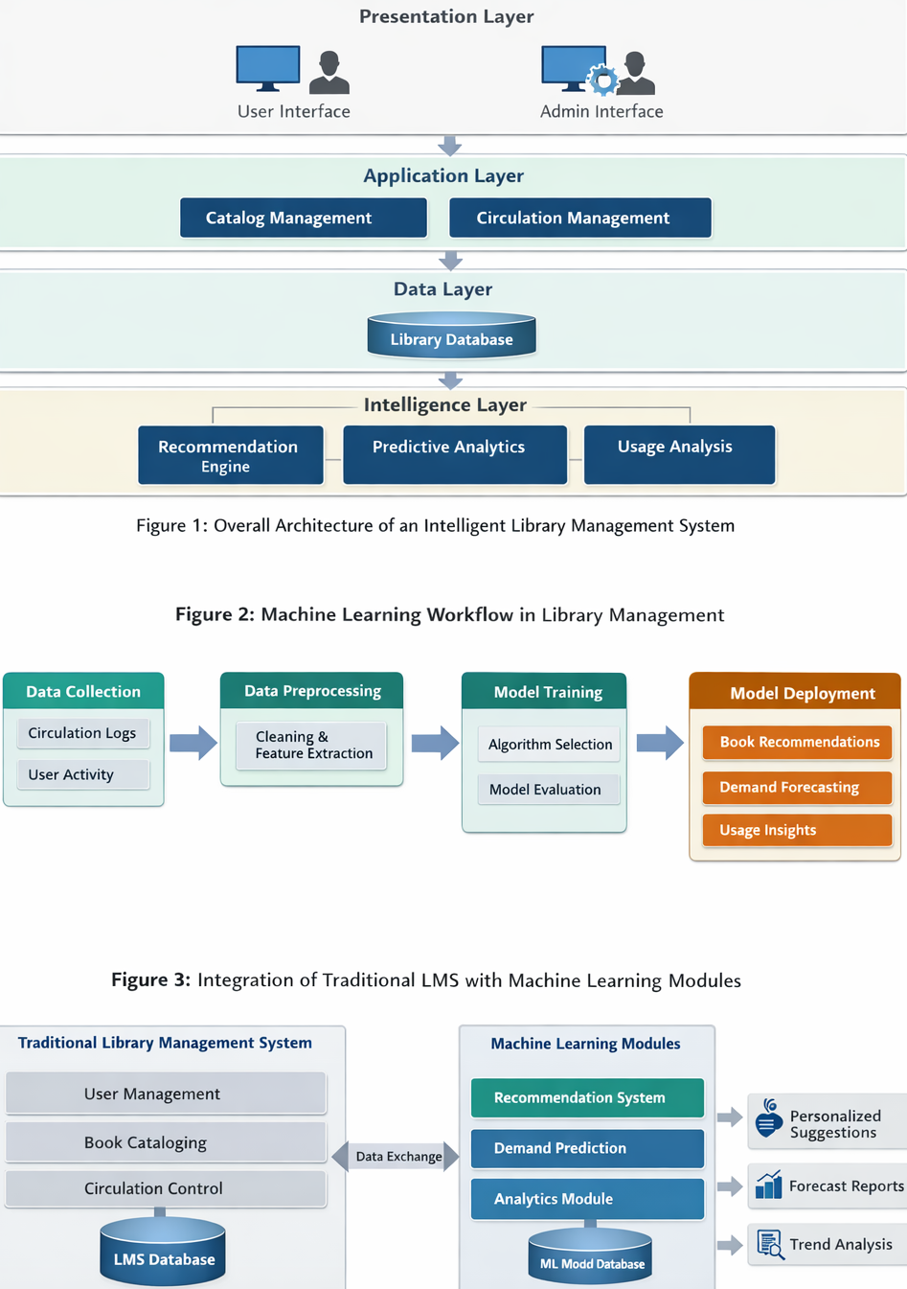
Figure 1: Overall Architecture of an Intelligent Library Management System
This figure illustrates a layered architecture designed to support intelligent library operations. The presentation layer provides web-based interfaces for users and administrators. The application layer manages core library services such as cataloging and circulation. The data layer stores structured transactional information in a relational database. The intelligence layer applies machine learning models to analyze historical data and generate recommendations, predictions, and analytical insights.

Figure 2: Machine Learning Workflow in Library Management
This figure represents the complete machine learning pipeline used in intelligent library systems. It begins with data collection from circulation records and user interactions, followed by data preprocessing and feature extraction. Machine learning models are then trained and evaluated before deployment. The final outputs include personalized recommendations, demand forecasts, and usage trend analysis.

Figure 3: Integration of Traditional LMS with Machine Learning Modules
This diagram demonstrates how an existing library management system can be enhanced through the addition of machine learning modules. The traditional LMS continues to handle transactional operations, while ML components analyze stored data and provide intelligent insights without disrupting routine workflows.

VII. System Implementation Using Existing LMS
To demonstrate practical feasibility, this study considers the implementation of intelligent features using an existing Online Library Management System developed with PHP and MySQL.
A. Existing System Overview
The system follows a client–server architecture, where users interact with the application through web-based interfaces developed using PHP, HTML, CSS, and JavaScript. The back-end operations are supported by a MySQL relational database. The system automates essential library functions such as user management, book cataloging, issuing, and returning of books. Separate interfaces are provided for administrators and users. Administrators manage book records, categories, and user accounts, while users can search the catalog and issue books. Transactional integrity is maintained through server-side validation and structured database design.

B. Database Design
The database plays a critical role in system functionality. Key tables include:
- Books Table: Stores book identifiers, titles, authors, categories, availability status, and issue counts
- Users Table: Maintains user credentials, roles, and profile information
- Issue Table: Records issuing and returning transactions with timestamps
- Category Table: Organizes books based on subject domains
This structured schema ensures data consistency and supports efficient querying, which is essential for both daily operations and future machine learning analysis.

C. Functional Modules
- User Management Module
Manages registration, authentication, and role-based access control.
- Book Management Module
Allows administrators to add, update, delete, and categorize library resources.
- Circulation Module
Handles book issuing and returning while updating availability in real time.
- Reporting Module
Generates reports such as issued books, overdue items, and frequently borrowed titles.

D. Machine Learning Integration
Machine learning functionality can be integrated as an additional analytical layer. Circulation data stored in the MySQL database serves as the primary dataset. Features such as borrowing frequency, user history, and book popularity are extracted and processed using external ML tools, typically implemented in Python.
The trained models generate outputs such as book recommendations, demand predictions, and resource utilization insights. These outputs can be displayed within the PHP interface or used by administrators to support strategic decision-making.

E. Intelligent Features Enabled
The integration of ML enables the following intelligent services:
- Personalized book recommendations based on user behavior
- Demand forecasting to support acquisition planning
- Identification of underutilized resources
- Analytical insights into user reading patterns

F. Deployment Considerations
Machine learning processes can be executed asynchronously to ensure that core library operations remain unaffected. Security measures such as access control, encrypted data transfer, and anonymization of user data are essential to maintain privacy and system integrity. This layered integration approach allows institutions to gradually adopt intelligent features without overhauling existing infrastructure.

VIII. Future Scope
Although machine learning–based library management systems have shown strong potential in improving automation and personalization, several opportunities remain for future enhancement. One important direction is the development of fully integrated intelligent architectures where machine learning models are embedded directly into core library management workflows rather than operating as external or standalone components. Such integration would enable real-time intelligence across circulation, cataloging, and user interaction modules.
Future research can also focus on scalable and cloud-enabled deployments that support large user bases and multiple institutions. By combining cloud infrastructure with machine learning pipelines, libraries can achieve better performance, availability, and collaborative data analysis while reducing local infrastructure requirements.
Another promising area is the adoption of advanced learning techniques, such as deep learning and reinforcement learning, to improve recommendation accuracy and adaptive decision-making. These models can better capture complex user behavior and evolving reading preferences over time.
Privacy-preserving and ethical machine learning is another critical research direction. Future systems should incorporate data anonymization, secure access control, and compliance with data protection regulations to ensure user trust and responsible use of personal data.
Additionally, the integration of conversational interfaces and intelligent assistants, such as chatbots and voice-based systems, can significantly enhance accessibility and user engagement. These interfaces can assist users in searching resources, renewing books, and receiving personalized recommendations.
Finally, future studies should emphasize large-scale real-world evaluation using standardized datasets and performance metrics. Such evaluations are essential to assess system robustness, generalization capability, and long-term impact on library operations.

IX. Conclusion
This paper presented a comprehensive review of ten recent studies focused on machine learning-based library management systems. The analysis shows that while ML techniques significantly enhance personalization, prediction, and decision support, most existing solutions remain fragmented and limited to experimental setups. Fully integrated intelligent architectures are still lacking.
The study concludes that future library management systems should combine robust database-driven operations with embedded machine learning models, supported by scalable and secure system designs. Addressing integration challenges and emphasizing real-world deployment will be essential for the successful adoption of intelligent library systems in academic institutions.

